CONFIDENTIAL AND PROPRIETARY

Aries Systems Corporation

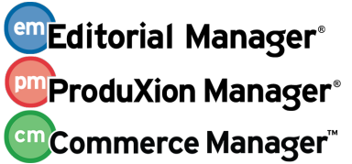

Product Functional Specification

14.0-02_V4

Suppress Enterprise Analytics and Cross-Publication Enterprise Analytics Standard Reports

Status: Ready for Engineering Hand-off

Copyright © 2016, Aries Systems Corporation

This document is the confidential and proprietary property of Aries Systems Corporation. The contents hereof are for use only by recipients specifically identified by Aries, and may not be further disclosed to any other third party. Specifications, designs and drawings contained herein are subject to withdrawal or change by Aries, without notice. Aries shall have no liability resulting from such withdrawal or change. Editorial Manager is a registered trademark and the property of Aries Systems Corporation.

Aries Systems reserves the right to share this specification with other individuals or organizations that have entered into confidentiality agreements with Aries Systems, in which case the specification will be appropriately blinded so that no identifying or proprietary information will be exposed.
Document Summary

Enhancement Name | Suppress Enterprise Analytics and Cross-Publication Enterprise Analytics Standard Reports
Specification Number | 14.0-02
Enhancement Type | General
Implemented In | Hotfix to 13.1

Document Revision History

Date | Author | Comments
4/12/2016 | BNeale | V1 – Initial draft based on FRA
4/29/2016 | BNeale | V2 – Peer Review updates
5/9/2016 | BNeale | V3 – Add Test Cases
5/25/2016 | BNeale | V4 – Add EAR/XEAR warning page when no Standard, Custom or Shared Reports exist

Specification Approvals
Department | Date | Version | Name
Corporate | 5/11/2014 | V3 | L. Holmes
Product Mgt. | 5/11/2014 | V3 | T. Alves
Engineering | 5/11/2014 | V3 | B. Massicotte
Operations | 5/11/2014 | V3 | M. Martini
Customer Service |  | V3 | J. Fleet
Aries KG |  | V3 | R. Nottebaum
Sales | 5/11/2014 | V3 | R. Wynne
Table of Contents

1 Overview 1
1.1 Glossary 1
1.2 Related Specifications 2
1.2.1 Specification 8.0-04 Enterprise Analytics Reporting 2
1.2.2 Specification 8.0-25 Scheduling and E-mailing EAR Reports 2
1.2.3 Specification 9.0-23A EAR and UDB Integration Phase 1 2
1.2.4 Specification 10.0-62 Cross Portal Author and Reviewer Invitation Statistics Display 2
1.2.5 Specification 10.0-73 Duplicate Submission Check 2
1.2.6 Specification 11.0-32 UDB EAR Sub Groups 2
1.3 Spec13.0-44 - Limit Publications for Xpub Ear Functionality 2
2 Application Impact 3
2.1 AdminManager Main Menu [AdminManager.aspx] 3
2.2 Configure Enterprise Analytics Reporting Menus [newpage.aspx] 4
2.3 Configure Enterprise Analytics Reporting Menus Confirmation [newpage.aspx ] 5
2.4 Enterprise Analytics Reporting [enterpriseReports.aspx] 6
2.5 Cross-Publication Enterprise Analytics Reporting [enterpriseReports.aspx] 7
3 Database Impact 9
3.1 DB Content Changes 9
3.2 UDB Impact 9
4 Multi-Lingual Considerations 9
5 Performance Processing Impact 9
5.1 Performance Requirements 10
5.1.1 Data Server 10
5.1.2 Web Server 10
5.1.3 Network 10
5.1.4 Client Machine 10
5.2 Engineering Assessment 10
5.2.1 Engineering Test Results 10
6 Merge Field Impact 10
7 Upgrade Script Impact 10
8 Site Cleanout 10
9 Report Implications 10
9.1 Canned Reports 11
9.2 General Data Export 11
9.3 Custom Reports 11
9.4 Enterprise Analytics Reporting 11
9.5 Cross-Publication EAR 11
10 Hosting Documentation Impact 11
11 Portal (IJRS,etc.) Impact 11
12 Hosting Administration Impact 11
12.1 Hosting Administration Audit Trail 11
13 Sys Admin Audit Trail 11
14 Import/Export Impact 11
15 Transfer Impact 12
16 Cross-Publication Impact 12
17 Documentation and Training 12
18 Operations’ Considerations 12
18.1 Journal Rename 12
18.2 Journal Redirects 12
19 Utilities 12
20 Audit/Monitor/Diagnostics 12
21 Journal Configuration 12
22 Style Sheet impact 12
23 Deployment Considerations 13
23.1 Associated Revenue Model 13
23.2 Sales and Marketing Rollout Anticipation 13
23.3 Customer Service Rollout Preparation 13
23.4 Release Target 13
24 Future Development 13
25 Mobile Considerations 13
26 Use Cases and Test Scenarios 13
26.1 Regression Test Cases 13
26.2 Specification Test Cases 13
27 Appendix A: Technical Specification 16

Overview
In current functionality, for publications with the Enterprise Analytics Reporting enabled, a ‘Standard Reports’ fieldset is displayed on the Enterprise Analytics Reporting menu.
- For sites that are not enabled for Production Tracking, the fieldset contains a folder labelled ‘Editorial Reports’.
- For sites that are enabled for Production Tracking, the fieldset contains two folders – one labelled ‘Editorial Reports’ and one labelled ‘Production Tracking Reports’.
- Both folders are collapsible.

The sponsoring customer wants to suppress these Aries-created standard reports on the Enterprise Analytics Reporting (EAR) menu (i.e. suppress the entire Standard Reports fieldset). For consistency, the ability to suppress the standard reports fieldset on the Cross-Publication EAR menu is also included in this specification.

A new AdminManager> Configure Enterprise Analytics Reporting Menus page is created, allowing the publication to suppress the display of the Standard reports fieldset on the single journal Enterprise Analytics Reports (EAR) menu and the Cross-Publication Enterprise Analytics Reporting (XEAR) menu, as a global (publication-wide) setting. Note: it is created in AdminManager because some existing Cross-Publication Enterprise Analytics Reporting functionality (Manage Publication Groups) is already in AdminManager.
- Upon upgrade, for all publications with the Enterprise Analytic Reporting feature enabled will display the new ‘Configure Enterprise Analytics Reporting Menus’ page link on the AdminManager Main Menu.
- The new ‘Display all standard Enterprise Analytics reports for all Editor Roles’ checkbox defaults to selected/checked/enabled on the new configuration page displaying the Standard reports. The user sees no change at upgrade.
- When the new configuration is set to suppress the Standard reports fieldset, all Editors with permission to create Enterprise Analytic Reports and/or Cross-Publication Analytic Reports, no longer see the Standard reports section when viewing the Enterprise Analytics Reporting and Cross-Publication Enterprise Analytics Reporting pages.

Glossary
EAR – This is an acronym for Enterprise Analytics Reporting.

XEAR – This is an acronym for Cross-Publication Enterprise Analytics Reporting

Launch Points – This refers to the various pages where a user can initiate a workflow/ action link.

Related Specifications

Specification 8.0-04 Enterprise Analytics Reporting
Specification 8.0-04 (Version 8.0) incorporated the Izenda reporting product in to EM/PM as “Enterprise Analytics Reporting” (EAR). EAR is an add-on to existing EM/PM report features and is enabled in Hosting Administration.

Specification 8.0-25 Scheduling and E-mailing EAR Reports
Specification 8.0-25 (Version 8.1) added the ability to email EAR reports and schedule EAR reports and added additional tables to the “Data Sources” drop down list.

Specification 9.0-23A EAR and UDB Integration Phase 1
Specification 9.0-23A (Version 9.2) introduced cross-publication reporting for Publishers with more than 50 publications. The specification provided an interface between Cross-Publication Enterprise Analytics Reporting (Cross-Pub EAR) and a publisher-specific Unified Database (UDB).

Specification 10.0-62 Cross Portal Author and Reviewer Invitation Statistics Display
Specification 10.0-62 (Version 10.2) added functionality when publications are configured to share Reviewer information between publications (configured on the Define Reviewer Sharing Partners page in AdminManager), and the journal’s Business Publisher has a Unified Database (UDB). If so, then additional information is pulled from the UDB and is displayed on all Search for Reviewers and Search for Authors results pages.

Specification 10.0-73 Duplicate Submission Check
Specification 10.0-73 (Version 10.2) introduced a new method of Duplicate Submission Check that searches either the single journal database or a Publisher’s UDB and checks a submission against previously submitted manuscripts for similarity across Article Title, the list of Authors, and the Abstract.

Specification 11.0-32 UDB EAR Sub Groups
Specification 11.0-32 (Version 11.2) introduced functionality whereby publications can define Publication Groups for Cross-Publication EAR.

Spec13.0-44 - Limit Publications for Xpub Ear Functionality
The Hosting Administration/Set Journal Features page is modified to allow Aries Account Coordinators to define the list of publications that are to be included in the “All Publications for the Business Publisher” default group for each EM site – the list can be an inclusive list or an exclusive list.

Application Impact
The following pages are impacted in this EM specification:
- AdminManager Main Menu is enhanced to add a new page link - 2.1
- New Configure Enterprise Analytics Reporting Menus page - 2.2
  - New Configure Enterprise Analytics Reporting Menus Confirmation page when changes are submitted. - 2.3
- Enhance Enterprise Analytics Reporting page to check the state of the new configurations - 2.4
- Enhance Cross-Publication Enterprise Analytics Reporting page to check the state of the new configurations - 2.5

AdminManager Main Menu [AdminManager.aspx]
For publications where the Hosting Administrator has the ‘Enterprise Analytics Reporting’ feature enabled/configured/selected, upon upgrade displays a new page link on the existing AdminManager Main Menu [AdminManager.aspx] after the existing ‘Manage Publication Groups’ page link, titled Configure Enterprise Analytics Reporting Menus page link.

When this new Configure Analytics Reporting Menus page link is selected, the user navigates to the new AdminManager> Configure Analytics Reporting Menu page which allows the suppression of the EAR and Cross-Pub EAR Standard Reports fieldsets globally for all Editor Roles.

Figure 1: Existing AdminManager Main Menu page with the new Configure Enterprise Analytics Reporting Menus displays.
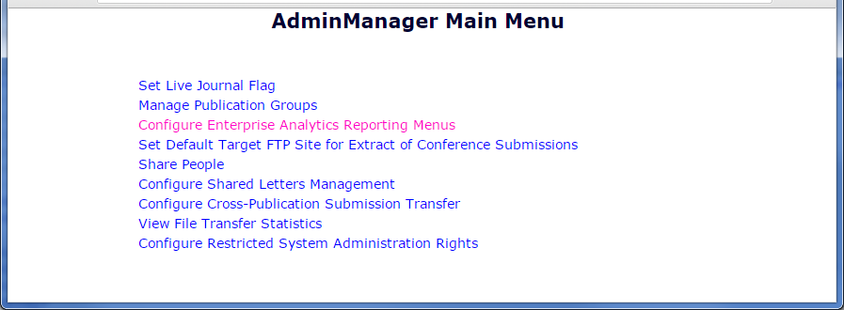

Configure Enterprise Analytics Reporting Menus [newpage.aspx]
This new page is reached by System Administrators after selecting the new AdminManager>Configure Enterprise Analytics Reporting Menus page link.

Layout:
- Page Title: “Configure Enterprise Analytics Reporting Menus”
- Instructional text centered in the gray box, “To display the Standard Reports section of the Enterprise Analytics Reporting menu(s), select the checkbox and click the Submit button.”
- Checkbox with the label “Display all standard Enterprise Analytics reports for all Editor Roles”
  - Upon upgrade, the checkbox defaults to selected/enabled/checked.
- ‘Cancel’ button – when selected, does not save the changes made to the page and the user is returned to the AdminManager Main Menu page.
- ‘Submit’ button – when selected, saves the state of the new checkbox to the database and logs the change to the AdminManager Audit Trail.
  - A new Configure Enterprise Analytics Reporting Menus confirmation page displays - Figure 4
- This new page layout is similar to the existing Configure Shared Letters Management [ConfigureSharedLetters.aspx] page.

Figure 2: New Configure Enterprise Analytics Reporting Menus page at Upgrade. The new ‘Display all standard Enterprise Analytics reports for all Editor Roles’ checkbox defaults to selected/enabled/checked. The Standard Reports section displays.
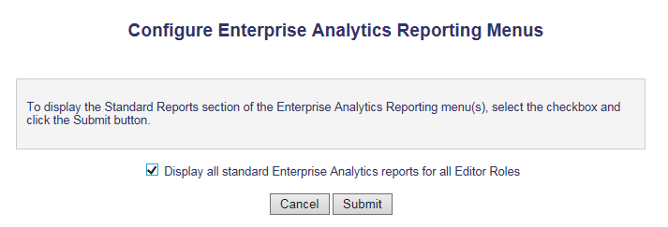

Figure 3: The new Configure Enterprise Analytics Reporting Menus page when the new ‘Display all standard Enterprise Analytics reports for all Editor Roles’ is unselected/disabled/unchecked. When this is submitted, the Standard Reports section is suppressed.
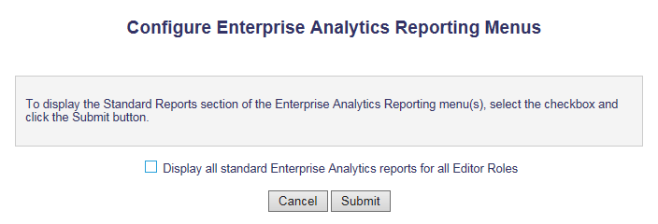

Configure Enterprise Analytics Reporting Menus Confirmation [newpage.aspx ]

This new Configure Enterprise Analytics Reporting Menus Confirmation page displays when a System Administrator selects the ‘Submit’ button from the new AdminManager >Configure Enterprise Analytics Reporting Menus page.

Layout:
- Page Title: “Configure Enterprise Analytics Reporting Menus Confirmation”
- Confirmation Text: “Your Enterprise Analytics Reporting Menus choice has been updated.”
- Navigational links:
  - Back to Configure Analytics Reporting Menus – when selected the user is returned to the new Configure Analytics Reporting Menus page.
  - PolicyManager Main Menu – when selected displays the PolicyManager Main Menu [PolicyManager.aspx] page.
- This page layout is similar to the existing Configure Shared Letters Management Confirmation [ConfigureSharedLetters.aspx] page.

Figure 4: New Configure Enterprise Analytics Reporting Menus Confirmation page displays after a System Administrator selects the ‘Submit’ button from the new Configure Enterprise Analytics Reporting Menus page.
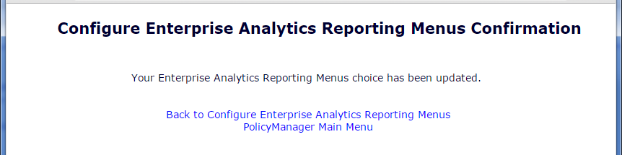

Enterprise Analytics Reporting [enterpriseReports.aspx]
This existing Enterprise Analytics Reporting page is reached by Editors with RoleManager permissions to create Enterprise Analytics Reports from the following launch points:
- Editor Main Menu>Reports>Enterprise Analytics Reporting page link
- For publications with Production Tracking feature enabled by the Hosting Administration, the Production Tasks Main Menu>Reports section.

This page is enhanced to look at the state of the new “Display all standard Enterprise Analytics reports for all Editor Roles” checkbox introduced in this EM Specification. Refer to section 2.2.
- Upon upgrade, the new checkbox is selected/enabled/checked, so the page displays the ‘Standard Reports’ section for all Editor Roles. - Figure 5
- When the state of the checkbox is unselected/disabled/unchecked, this page is enhanced to suppress the entire ‘Standard Reports’ section.

If there are no configured Custom or Shared reports and the new “Display all standard Enterprise Analytics reports for all Editor Roles” checkbox is disabled/unchecked/unselected, when an Editor opens the page, a message is displayed on the page: - Figure 6
- A message is displayed centered on the right side, above the navigational links with the following text, “There are currently no configured reports.”
- style=" color: #A9A9A9;font-size:14px;font-style: italic;"
- Figure 5: Existing Enterprise Analytics Reporting page showing the Standard Reports section that continues to display, upon upgrade.
- This is the current EAR main menu for a site using both Editorial and ProduXion Manager, in collapsed mode.
- Note: shared reports are customized reports created on the site by the publication.
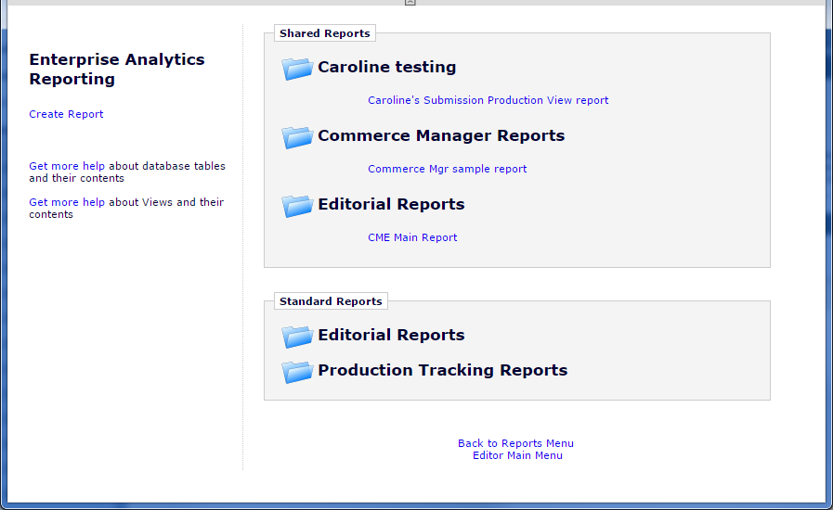

Figure 6: Enhanced Enterprise Analytics Reporting page displays a message for publication sites with no Custom, Shared reports with the Standard Reports section suppressed.
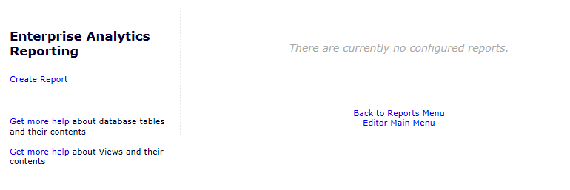

Cross-Publication Enterprise Analytics Reporting [enterpriseReports.aspx]
This existing Cross-Publication Enterprise Analytics Reporting [enterpriseReports.aspx] page is reached by Editors with RoleManager permissions to create Cross-Publication Enterprise Analytics Reports from the following launch points:
- Editor Main Menu>Reports>Cross-Publication Enterprise Analytics Reporting page link
- For publications with Production Tracking feature enabled by the Hosting Administration, the Production Tasks Main Menu>Reports section.

This page is enhanced to look at the state of the new “Display all standard Enterprise Analytics reports for all Editor Roles” checkbox introduced in this EM Specification. Refer to section 2.2.
- Upon upgrade, the new checkbox is selected/disabled/unchecked, so the page displays the ‘Cross-Publication Standard Reports’ section. - Figure 7
- When the state of the checkbox is unselected/disabled/unchecked, this page is enhanced to suppress the entire ‘Cross-Publication Standard Reports’ section.

If there are no configured Custom or Shared reports and the new “Display all standard Enterprise Analytics reports for all Editor Roles” checkbox is disabled/unchecked/unselected, when an Editor opens the page, a message is displayed on the page: - Figure 8
- A message is displayed centered on the right side, above the navigational links with the following text, “There are currently no configured reports.”
- style=" color: #A9A9A9;font-size:14px;font-style: italic;"

Figure 7: The existing Cross-Publication EAR Main Menu for a site using both Editorial and ProduXion Manager, in collapsed mode, without any custom publication groups.
- Note: shared reports are customized reports created on the site by the publication, and will vary among sites.
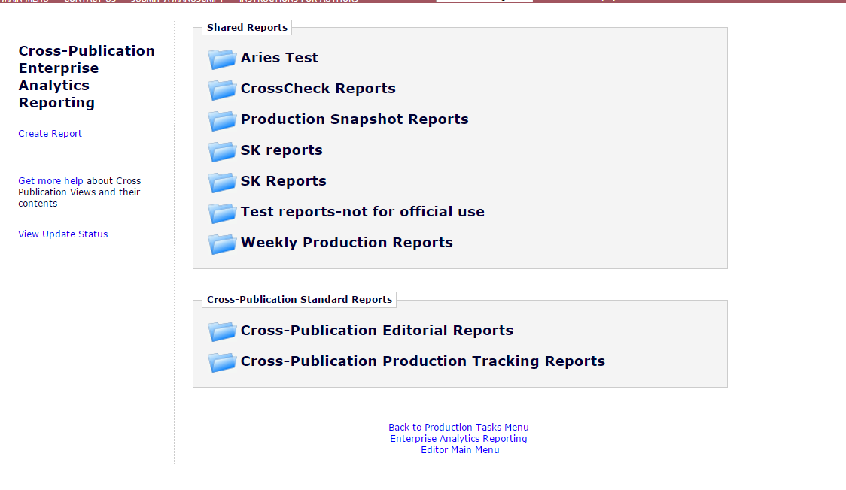

Figure 8: Enhanced Cross-Publication Enterprise Analytics Reporting page displays a message for publication sites with no Custom, Shared reports with the Standard Reports section suppressed.
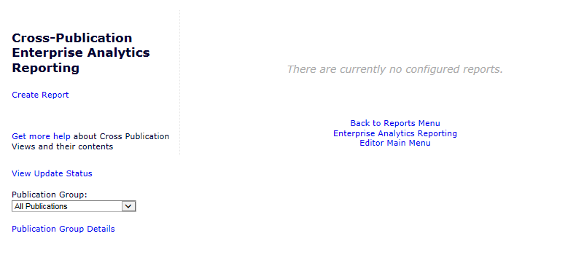

Database Impact
New field to store the state of the new Configure Enterprise Analytics Reporting Menus configuration checkbox introduced in this EM specification.

DB Content Changes
New Configure Enterprise Analytics Reporting Menus configuration checkbox state.

UDB Impact
None

Multi-Lingual Considerations
Tokenization for the two new pages introduced in this EM specification:
- Configure Analytics Reporting Menus page
- Configure Analytics Reporting Menus Confirmation page

Performance Processing Impact
There should be very minimal impact on performance when rendering the EAR and XEAR Reports Pages. This EM Specification introduces one new setting that retains the Standard Reports section or suppresses this section for ALL Editor roles. Suppressing the Standard Reports section, when configured, should improve the rendering to the screen because there is less content.

Consideration guidelines:
- 1,000,000 submissions per year
- 5,000,000 people records
- NOTE: Expectation that all testing be on PONECLONE

Performance Requirements

Data Server

Web Server

Network

Client Machine

Engineering Assessment

Engineering Test Results

Merge Field Impact
None

Upgrade Script Impact
The sponsoring client may request a script to enable the new configuration setting as part of the upgrade.

The default standard reports remain part of the main site, therefore all future upgrades should continue to updated these reports, if applicable. i.e. We still upgrade the default reports, whatever the condition of the main setting is, because the journal can reverse their decision at any time.

Site Cleanout

Report Implications
EAR and XEAR Standard Reports section is displayed/suppressed based on the new configuration page for All Editor Roles. No changes are made to individual reports.

Canned Reports
None

General Data Export
None

Custom Reports
None

Enterprise Analytics Reporting
New configuration is added in this EM specification to display/suppress the Standard Reports section on the Enterprise Analytics Reporting page. No changes are made to the reports.

Cross-Publication EAR
New configuration is added in this EM specification to display/suppress the Standard Reports section on the Enterprise Analytics Reporting page. No changes are made to the reports.

Hosting Documentation Impact

Portal (IJRS,etc.) Impact

Hosting Administration Impact
None.

Hosting Administration Audit Trail
Any changes made to any Hosting Administration code should include invocation of the HA Audit Trail code module to ensure that appropriate data about administration changes are recorded to the HA Audit Trail

Sys Admin Audit Trail
Any changes made to AdminManager code should include invocation of the Audit Trail code module to ensure that appropriate data about administration changes are recorded to the Audit Trail.

Import/Export Impact
None

Transfer Impact
None

Cross-Publication Impact
New configuration is added in this EM specification to display/suppress the Cross-Publication Standard Reports section on the Cross-Publication Enterprise Analytics Reporting page. No changes are made to the reports.

Documentation and Training

Operations’ Considerations

Journal Rename

Journal Redirects

Utilities
Consider any or all of the following with Engineering consultation:
- UDB Utility
- Upgrader
- IJRS Sync Tool
- Deleter
- Cloner
- Migrator
- Translation Utility

Audit/Monitor/Diagnostics
Used when going out to a 3rd party system to detect if the system is up. Add to an existing “Tembria dashboard”; indicate who should get e-mail notices if 3rd party goes down.

Journal Configuration
A new Configure Enterprise Analytics Reporting Menus page is created on the existing AdminManager menu. Publications requesting to suppress the Standard reports for all editors on the EAR and XEAR reporting pages can use this page to unselect/uncheck/disable the new checkbox.

Style Sheet impact
None

Deployment Considerations

Associated Revenue Model

Sales and Marketing Rollout Anticipation

Customer Service Rollout Preparation

Release Target
Hot Fix to 13.1

Future Development

Mobile Considerations
Functional considerations for smartphones and tablets (if applicable)

Use Cases and Test Scenarios

Regression Test Cases
- No changes are made to any of the EAR and XEAR reports programming. All reports should be regression tested.
- Editor RoleManager Permissions remain unchanged. Editors with and without permission to view the EAR and XEAR should continue to access/suppress the EAR and XEAR Reports pages. The only change is the content that displays on the page once the Editor initiates the launching of the page.
- Publications with the HA setting with ‘Enterprise Analytics Reporting feature turned off/disabled/unselected should reflect no changes by this EM specification.

Specification Test Cases
Configuration:
- Both a Single Publication (Pub A) and Cross-Pub Publication (Pub B) must be tested with the HA setting with ‘Enterprise Analytics Reporting’ feature and ‘Production Tracking’ turned on/enabled/selected.
- Single Publication (Pub C) with the HA setting with ‘Enterprise Analytics Reporting feature turned off/disabled/unselected.
- Editor Roles:
- Editor A with System Administrator permissions to access AdminManager.
- Editor B with ‘Produce Reports’ RoleManger permissions enabled/selected/checked for Single Publication.
- Editor C with ‘Produce Reports’ and ‘Run Cross-Publication Analytics Reports for All Publications’ with at least one selected publication RoleManger permissions enabled/selected/checked.
- Editor D with ‘Produce Reports’ RoleManager permission unselected/unchecked/disabled.

Test Cases:
- Test Case – Pub C with Editor A verify no change to AdminManager page. (Single Publication with EAR disabled.)
  - Upon upgrade, login in as Editor A and select the System Administration menu from the Editor Main Menu
  - Select AdminManager and confirm there is no change to the AdminManager menu and the new ‘Configure Enterprise Analytics Reporting Menus page link is suppressed.
- Test Case – Pub A with Editor A verify new page link is added to the AdminManager menu (Single pub with EAR enabled)
  - Upon upgrade, login as Editor A and select the System Administration menu from the Editor Main Menu
  - Select AdminManager and confirm the new ‘Configure Enterprise Analytics Reporting Menus’ page link is displayed on the AdminManager menu. Refer to Figure 1.
  - Select the new ‘Configure Enterprise Analytics Reporting Menus’ page link and confirm the new ‘Configure Enterprise Analytics Reporting Menus’ page is displayed as shown in Figure 2.
  - Confirm the label ‘Display all standard Enterprise Analytics reports’ checkbox is enable/selected/checked.
  - Unselect the checkbox so it is unchecked/unselected/disabled.
  - Select ‘Cancel’ button and confirm you are returned to the AdminManager Main Menu page.
  - Reopen the new page and confirm the checkbox is still selected and no changes were saved when you selected the ‘Cancel’ button. Select the ‘Cancel’ button again leaving the status of the checkbox selected/enabled/checked.
  - Navigate to the Editor Main Menu and select Reports>Enterprise Analytics Reporting menu options.
  - Confirm the Standard Reports section and the standard reports (including those for Production Tracking) are displayed on the page. Refer to Figure 5.
- Test Case – Repeat Test Case #2 using Pub B (Cross-Publication site with EAR enabled)
  - Repeat all of the steps in the Test Case #2 using the Cross-Publication site.
  - Navigate to the Editor Main Menu and select Reports>Cross-Publication Enterprise Analytics Reporting menu options.
  - Confirm the Cross-Publication Standard Reports section displays. Refer to Figure 7.
- Test Case – Confirm ALL Editor Roles display the Standard Reports section. Test both Pub A and Pub B.
  - Login as Editor B
  - Navigate to Editor Main Menu
  - Select Reports>Enterprise Analytics Reporting menu option
  - Confirm the Standard Reports section displays with the Editorial Reports and the Production Tracking Reports.
  - For Pub B (Cross-Publication site), select Back to Reports Menu and select Cross-Publication Enterprise Analytics Reporting menu and confirm the Cross-Publication Standard Reports section displays with the Cross-Publication Editorial Reports and Cross-Publication Production Tracking Reports.
- Test Case – Pub A with Editor A suppress the Standard Reports section AdminManager menu (Single pub with EAR enabled)
  - Login as Editor A and select the System Administration menu from the Editor Main Menu
  - Select AdminManager and confirm the new ‘Configure Enterprise Analytics Reporting Menus’ page link is displayed on the AdminManager menu. Refer to Figure 1.
  - Select the new ‘Configure Enterprise Analytics Reporting Menus’ page link and confirm the new ‘Configure Enterprise Analytics Reporting Menus’ page is displayed as shown in Figure 2.
  - Confirm the label ‘Display all standard Enterprise Analytics reports’ checkbox is enable/selected/checked.
  - Unselect the checkbox so it is unchecked/unselected/disabled. Refer to Figure 3.
  - Select ‘Submit’ button and confirm the new Configure Enterprise Analytics Reporting Menus Confirmation page displays. Refer to Figure 4.
  - Select the ‘Back to Configure Enterprise Analytics Reporting Menus’ navigational link and confirm you are brought to that page.
  - Select the ‘Submit’ button without making any changes and confirm the Confirmation page displays again. Select the ‘PolicyManager Main Menu’ navigational link and confirm you are brought to the PolicyManager Main Menu.
  - Navigate to the Editor Main Menu and select Reports>Enterprise Analytics Reporting menu options.
  - Confirm the Standard Reports section and the standard reports (including those for Production Tracking) are now suppressed on the page.
- Test Case – Repeat Test Case #5 using Pub B (Cross-Publication site with EAR enabled)
  - Repeat all of the steps in the Test Case #5 using the Cross-Publication site.
  - Navigate to the Editor Main Menu and select Reports>Cross-Publication Enterprise Analytics Reporting menu options.
  - Confirm the Cross-Publication Standard Reports section is now suppressed.
- Test Case – Confirm ALL Editor Roles suppress the Standard Reports section. Test both Pub A and Pub B.
  - Login as Editor B
  - Navigate to Editor Main Menu
  - Select Reports>Enterprise Analytics Reporting menu option
  - Confirm the Standard Reports section is now suppressed with the Editorial Reports and the Production Tracking Reports suppressed.
  - For Pub B (Cross-Publication site), select Back to Reports Menu navigational link and select Cross-Publication Enterprise Analytics Reporting menu and confirm the Cross-Publication Standard Reports section is now suppressed with the Cross-Publication Editorial Reports and Cross-Publication Production Tracking Reports suppressed.

- Test Case – Confirm the EAR and XEAR message displays when no Customer, Shared reports exist for the site and the Shared reports section is configured to suppress.
  - EM site with Enterprise Analytics Reporting is enabled and no custom or shared EAR and XEAR reports. Login as an Editor A and navigate to AdminManager> Configure Enterprise Analytics Reporting Menus, unselect the new “Display all standard Enterprise Analytics reports for all Editor Roles” checkbox and select ‘Submit’ button.
  - Confirm the Configure Enterprise Analytics Reporting Menus Confirmation page displays.
  - Login as Editor C and navigate to the Editor Main Menu>Reports>Enterprise Analytics Reporting page.
  - Confirm the page displays the message showing in both Figure 6 and Figure 8.
  - Create a custom report, anything to save a report.
  - Confirm the custom report fieldset displays with the newly saved custom report and the message from Step d. no longer displays.

Appendix A: Technical Specification

~ End of Specification ~

